|  |
| --- |
| mhsoftsolutions |
| Drug Control System |
|  |
| **Mihindu Wijesena** |
| **10/11/2015** |

|  |
| --- |
| Contains the configurations and user manual of the drug control system |

Contents

Introduction 3

Set up the System 3

System Requirements 3

Configure the system 3

Users Administration 4

To create a user 4

Change password 4

Main Screen 5

Inventory 5

Total by SR Number 7

Order Details 9

History 10

Drug Control System

# Introduction

Drug control system is design to track the drug details of your store. This is a windows based applications. (Windows7 and upwards)

There are two main functions

1. To Warn the user for drugs that are going to expire with in next 3 months
2. Warn the drugs that have reached the reorder level (REOL)

# Set up the System

Double click the 'setup.exe' file and follow the on screen instructions. You should have administrator permission to complete the installtion.

# System Requirements

* OS Windows 7 or higher
* 500Mb diskspace (Depend on your data)
* Dual core 1.2GHz or higher CPU
* Minimum 4GB RAM for 64Bit OS
* An Internet connection on installtion dependancies if necessary

# Configure the system

After a sucessfulll installtion, a Desktop Icon will be available

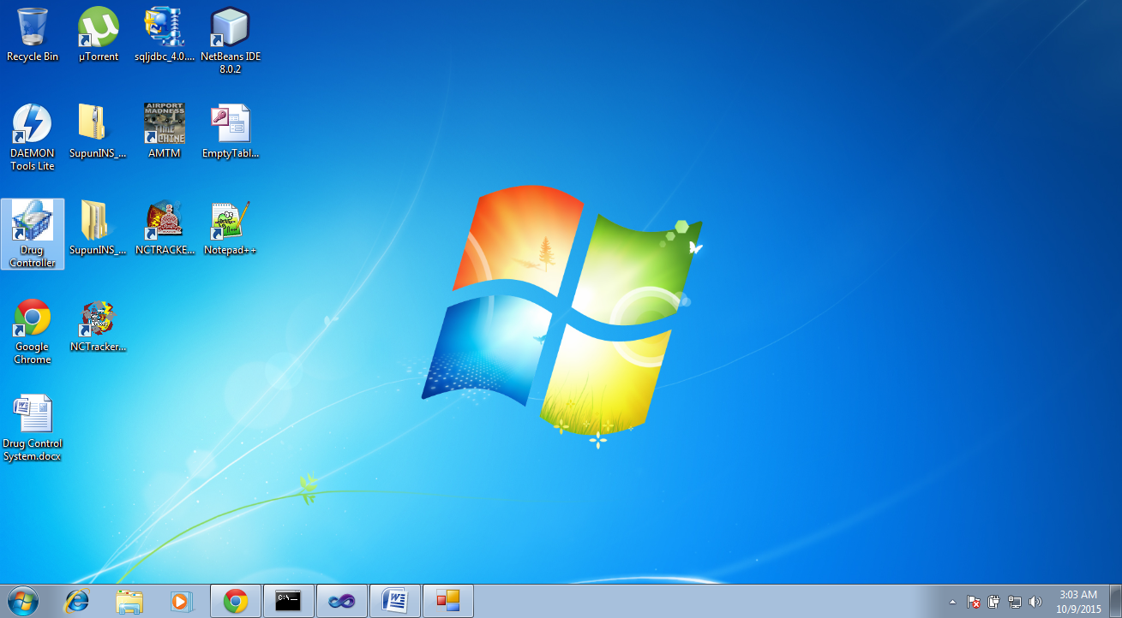Double click will open up the login screen

System is installed with pre configured user **Admin** with password **Admin** and users are stronly recommended to change the default passowrd.

## Users Administration

Admin user has the ability to create new users.

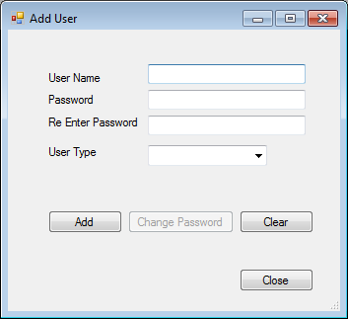

Currenlty system allows only two user types

1. Admin - Who has the full access to the system
2. User - Limited pre defined access to the system

### To create a user

1. Enter a user name
2. Enter password
3. Re Enter the password
4. Select a user type from the drop down
5. Press the **Add** button  
     
   If the user is already exists in the system, user details will be displayed .

### Change password

**Admin** type user can change the passwords of the other users. But users with the type **User**  will only be allowed to changed their own password.

1. Enter user name (**User** type users, wil get their name pre seleted)
2. Enter password
3. Re Enter the same password
4. Press **Chage Password**  button

## Main Screen

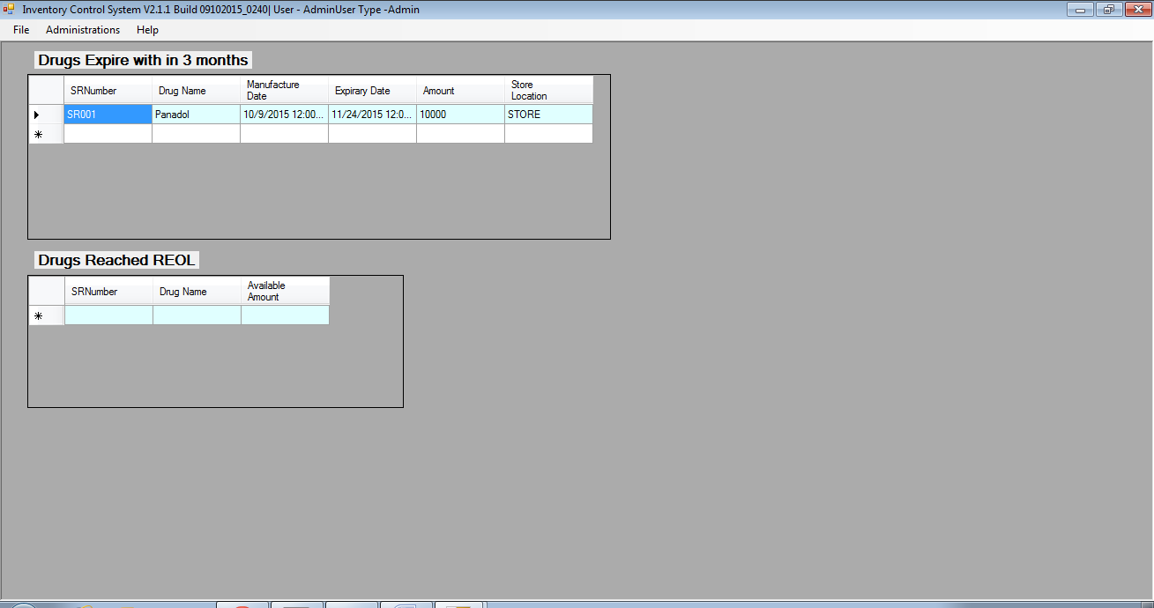

This is the main screen of the system, which allows the users to navigate to different windows in the system and also provide some valuable information.

## Inventory

File - - > Inventory

This is the main window of the system, where the user can enter Recieved or Issued drug details.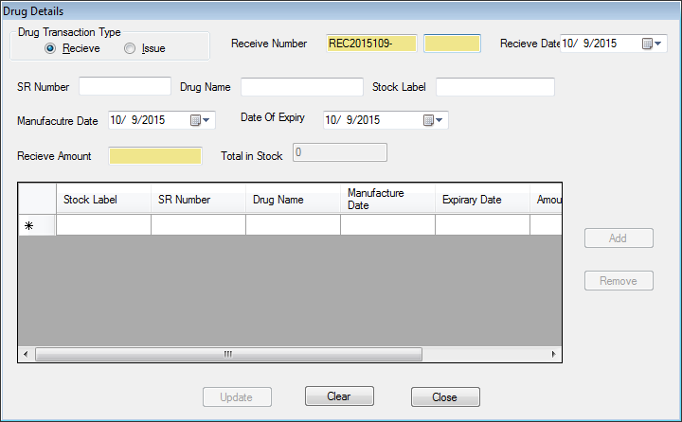

Recived or Issue number will be generated, and user must enter a value in order for the easy track.

It is possible to issue/Recive multiple drugs with once.

if a drug is added with the same SR Number, system will prompt if the system needs to retrive data from the data base for fields *Drug Name* and *Stock Label*

User should always press the add button, and add the record to the table, so that one order can have multiple drugs.

If the drug will expried with in next 3 months, as soon as **Update**  button is pressed, user will see it in the main screen

If user tryies to issue, it will not be possible Expired message will display inthe screen. But users are allowed to change the expirery date (V2.1.1 or lower + #13 is fixed in SUPUN_INS project in git hub)

## Total by SR Number

## 

File - - > Toatal per SR Number  
This will allow the users to get the total of drugs by SR Number.

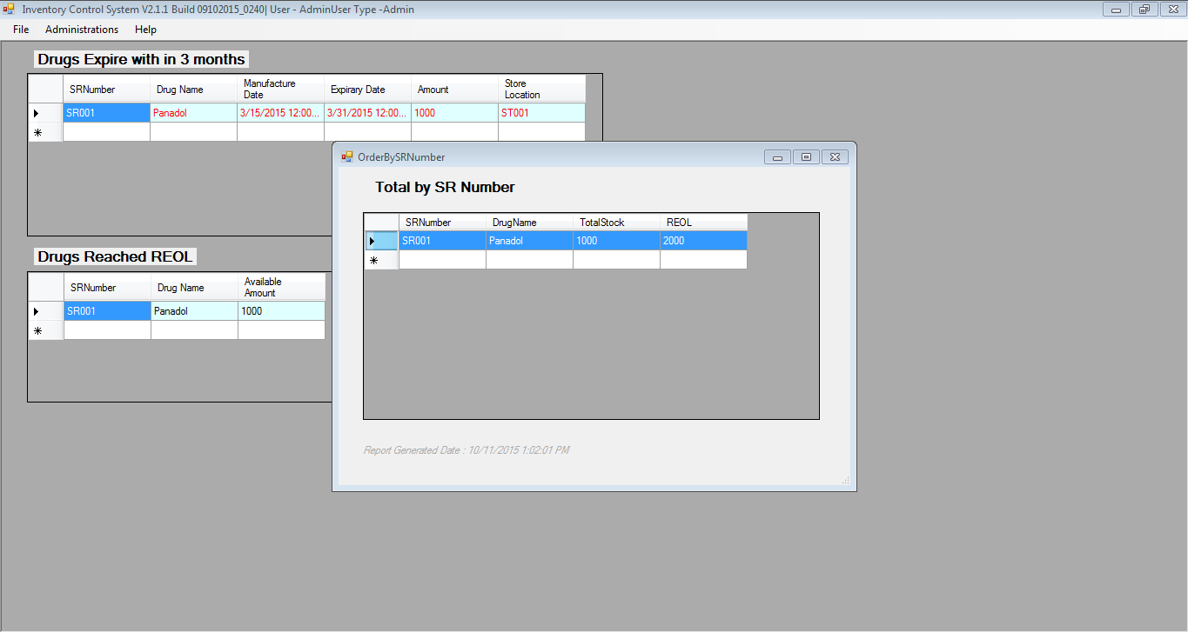Also allows the users to enter a REOL (Re Order Level value) of drugs. When drugs reached the REOL such drugs will be displayed in the main screen under 'Drugs Reached REOL'

REOL is specific to SR number, and can be added double clicking the specific drug

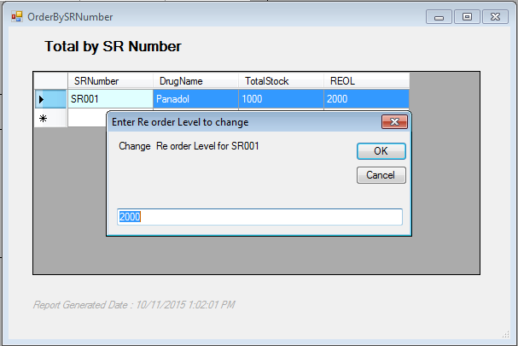

## Order Details

File - - > Order

All the order details will be displayed

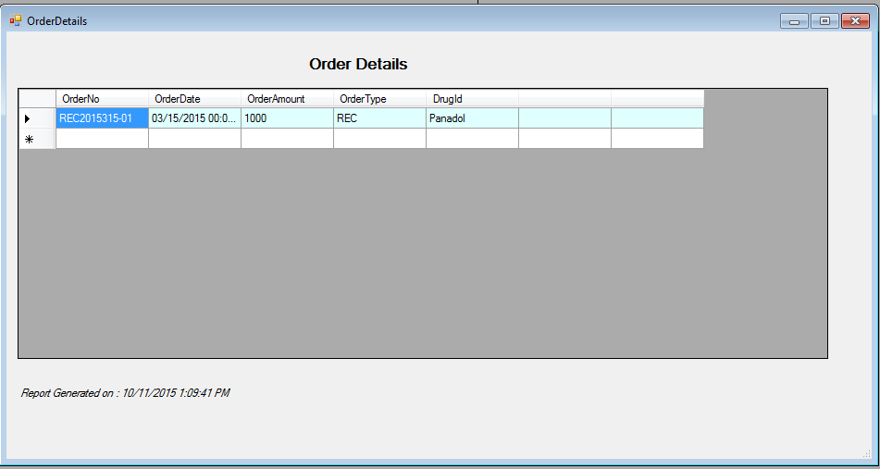

## History

Administration - - > History

It is possible to see the history of what has happned in the system.

